

|  |  |
| --- | --- |
|  | Asia Gateway Corporate Services  Your Online Receptionist  Agent User Guide |
|  |  |

Contents

1. Logging into your Agent Account 3

1.1 Log in 3

2. Understanding Your Agent Dashboard 4

2.1 Understanding Your Agent Dashboard 4

2.2 When an existing caller dials into the call centre 5

2.3 When a new caller / caller with private number dials into the call centre 6

3. Understanding FAQs Menu Tab (Frequently Asked Questions) 7

3.1 Looking up a question 7

3.2 Question not found in FAQs, what’s next? 8

4. Ticketing A Caller Problem 9

4.1 Raising a new Ticket 10

4.2 Managing Open Tickets 11

4.2.1 Viewing Details of an Open Ticket 12

4.2.2 Adding a Message to an Open Ticket 13

4.2.3 Escalating an Open Ticket Manually 14

4.2.4 Closing an Open Ticket 14

5. Warm Transfer 15

6. Concierge Services 16

7. History 17

Getting Started

Welcome and thank you for choosing online receptionist as your call centre management facility.

By now you would have received your Username & Password, kindly proceed to [www.online-receptionist.com/agent](http://www.online-receptionist.com/agent) to login to the call management system.

# Logging into your Agent Account

## 1.1 Log in

1. Enter your **Username** and **Password** provided to you into the Login
2. Enter the dynamic **Security Code** as shown in the figure below.

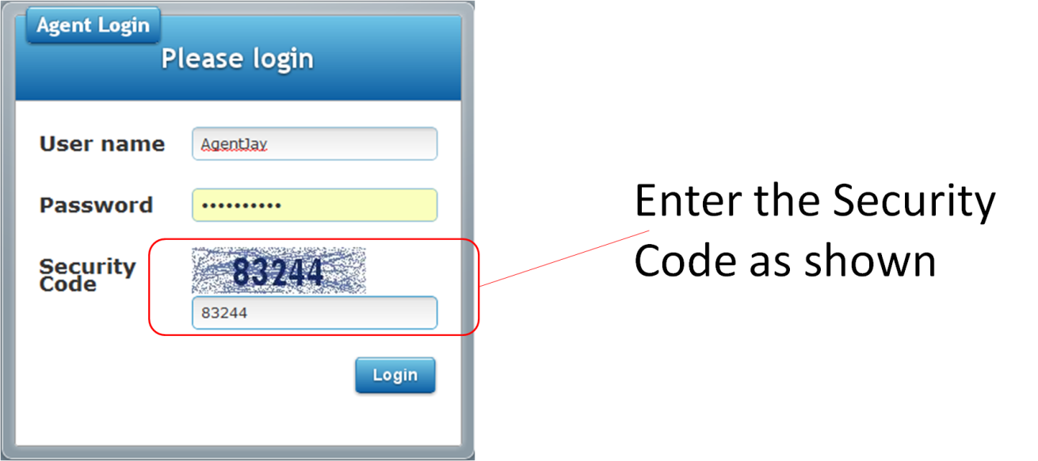

1. Click on the **Login** button.
2. If you have entered a wrong password or username, the system will prompt you to re-enter your correct username and password. Please note that your username and password is **case-sensitive**.

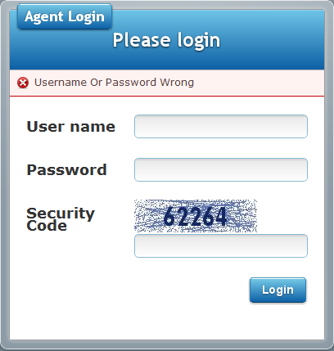

1. Understanding Your Agent Dashboard

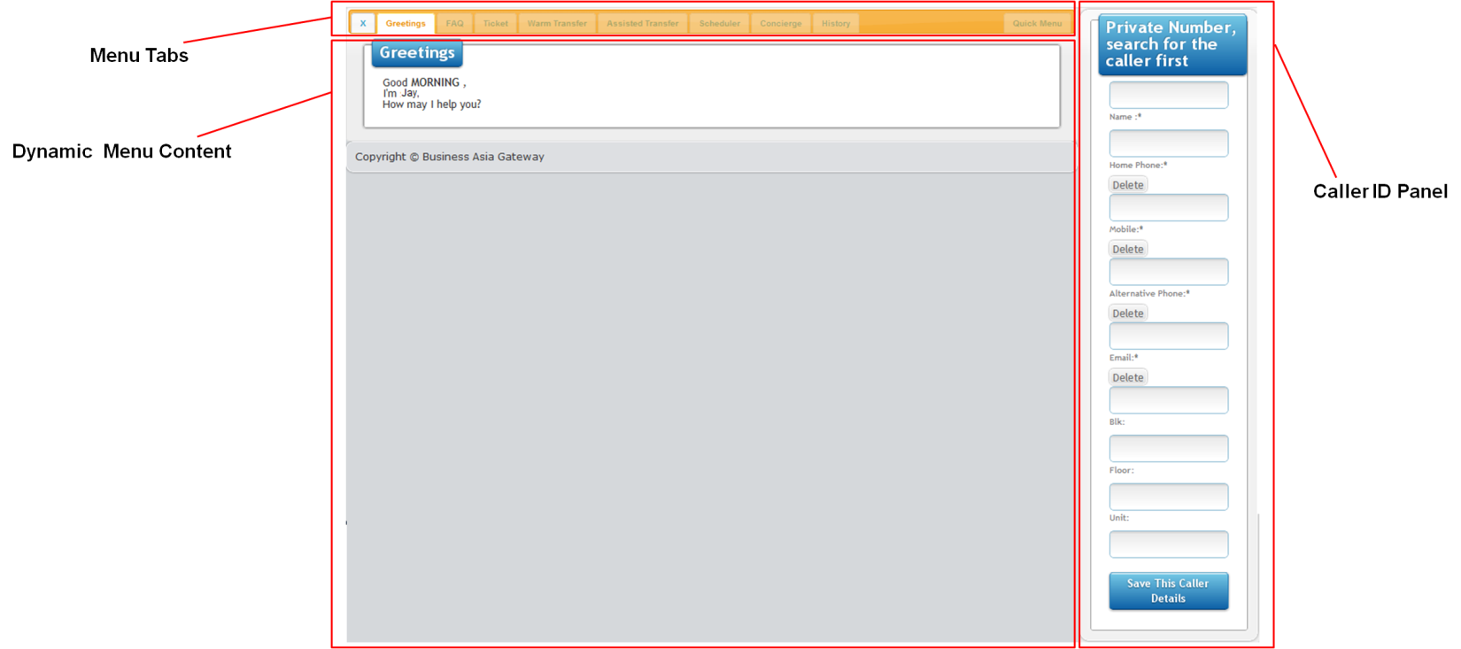

Figure 2a: Agent Dashboard

## 2.1 Understanding Your Agent Dashboard

After logging in correctly with your username and password. You will be brought to the **Agent Dashboard**.

The Agent Dashboard is split into 3 main sections as shown in Figure 2a.

In the top left hand corner, there is the interactive menu tabs, these tabs provide quick & easy access to call script information required by the call centre agent to respond to the caller.

The interactive menu tabs cover different aspects of a call centre agent requirements .

The following is a quick summary of each of the menu tab functionalities

|  |  |  |
| --- | --- | --- |
|  | **Greetings:** | This tab displays a greeting call script which is interactive and will adjust the call script according to caller’s preference on how to be addressed. |
|  | **FAQs:** | This tab displays Frequently Asked Questions, and can be referenced as a knowledge base. New questions can also be posted to the system and assigned to a staff member for an answer. |
|  | **Ticket:** | In the event, when a caller has dialed into the call centre for an issue to be resolved, a ticket can be raised by the call agent and can be assigned to the correct staff member for quick resolution. All tickets must be closed within the stipulated time allowance.  Failing to do so, will have the ticket automatically escalated to management level. |
|  | **Warm Transfer:** | Allows the agent to directly connect the caller to the another staff member for issue resolution. |
|  | **Assisted Transfer:** |  |
|  | **Scheduler:** |  |
|  | **Concierge:** | Allows the agent assist the caller in performing concierge tasks. |
|  | **History:** | Display a history of calls, that caller has made to the call centre. |

## 2.2 When an existing caller dials into the call centre

When an existing caller dials into the call centre, and is received by the Agent, the agent’s screen is updated with the caller’s contact information in the Caller ID panel ( as shown below )

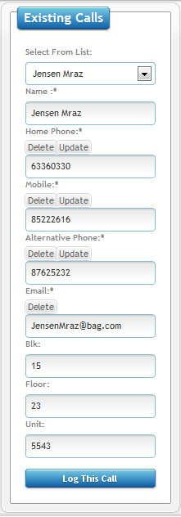 **Figure 2b: Existing caller information is updated**

1. Agent needs to log the caller by clicking the **Log This Call** button. This will then allow the other menu tabs to interactively be available to the agent. (See Figure 2b)
2. Agent will then be shown a dialog box to confirm that caller has been logged.

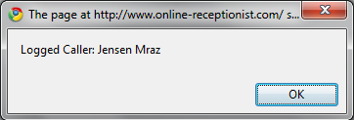 **Figure 2c: Caller Logged dialog box**

## 2.3 When a new caller / caller with private number dials into the call centre

When an new caller / caller with private number dials into the call centre, and is received by the Agent, the agent’s screen is updated left blank in the Caller ID panel ( as shown below )

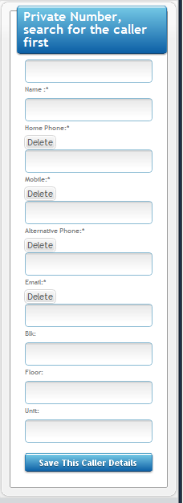 **Figure 2d: Private number contact form**

1. Where possible, Agent must obtain the name of the caller.
2. Agent should also obtain the contact information of the caller.
3. Upon full update of the caller information, caller can then click on the “**Save This Caller Details**” button. (in figure 2d)

# 3. Understanding FAQs Menu Tab (Frequently Asked Questions)

When an agent click on the FAQs tab, they are brought to the FAQs content. (as shown below)

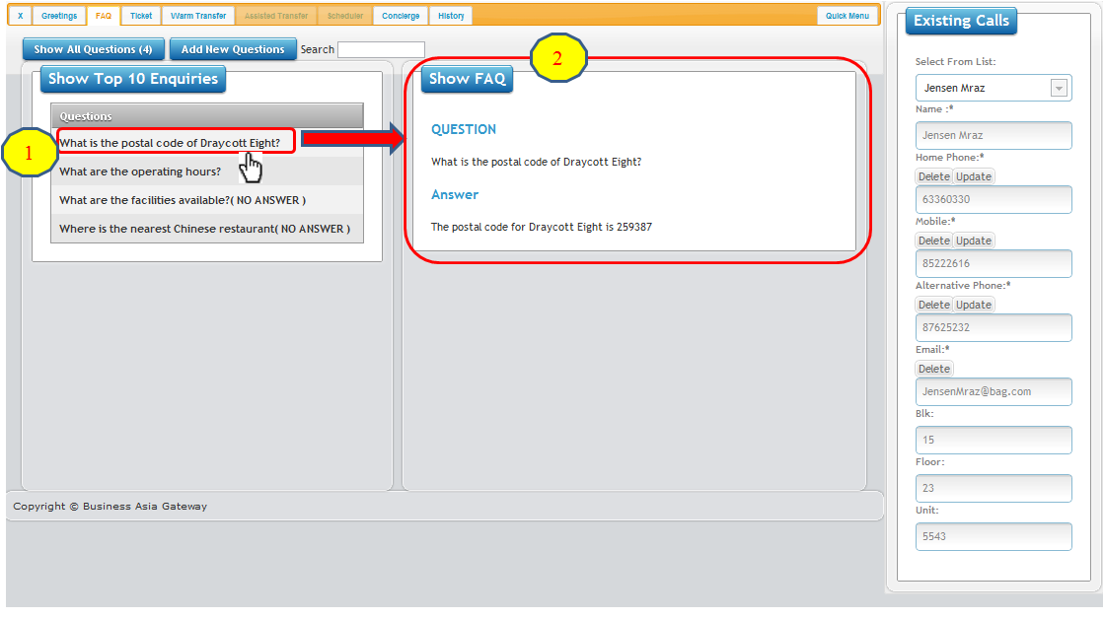

**Figure 3a: FAQs Tab**

## 3.1 Looking up a question

1. The FAQs will always show the Top 10 FAQs asked recently.
2. Clicking on a question as shown in **Figure 3a,** will open up another section to display the answer.

## 3.2 Question not found in FAQs, what’s next?

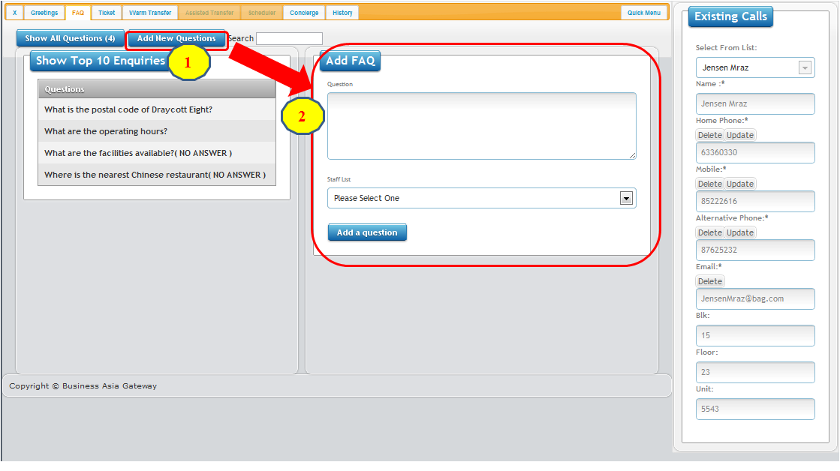

**Figure 3b: New FAQs**

1. For adding new FAQs as queried by caller, agent should enter the new questions into the FAQs knowledge base.
2. Click on the **Add New Questions** button.
3. The content will now display a **Add FAQ** Form
4. Agent should type in the question and assign to a staff member from the drop down menu “Staff List”
5. Agent should then click on **Add a question** button.
6. A FAQ assignment dialog box will pop-up as shown in **Figure 3c.**

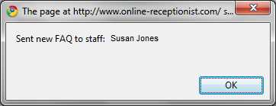 **Figure 3c: New FAQ Assigned dialog box**

Call & Issue Resolution

# 4. Ticketing A Caller Problem

When a caller has an issue or a question that cannot be resolved within the duration of a phone conversation,

a ticket needs to be raised to ensure that problem is tracked and resolved.

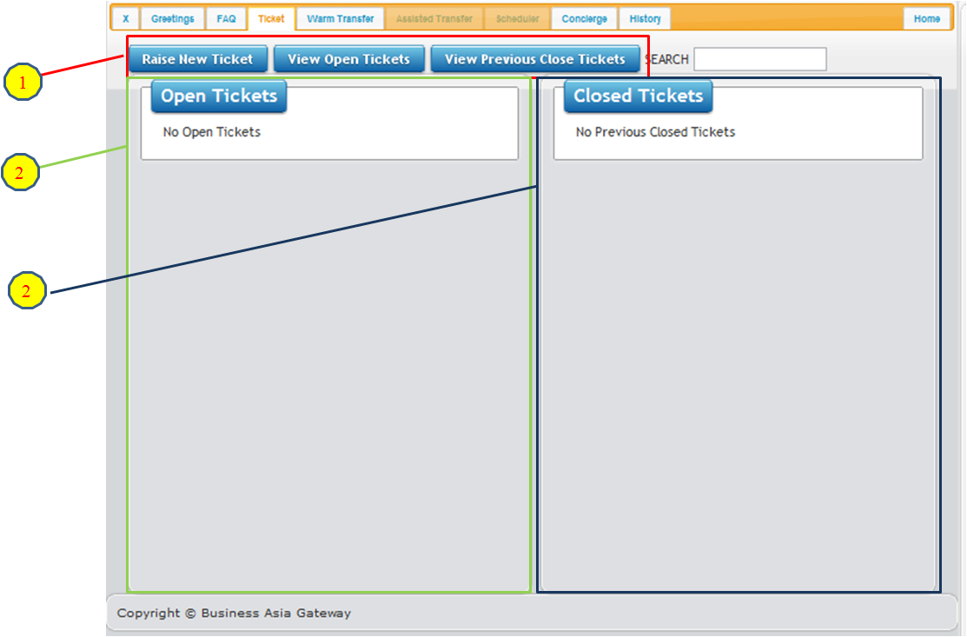

**Figure 4a: Ticket Management Dynamic Content Windows**

1. Navigating between ticketing tasks
   1. **Raise New Ticket**: click this button to raise a new caller issue
   2. **View Open Tickets**: click this button to check if caller has unresolved issues.
   3. **View Previous Close Tickets:** click this button to review past issues that caller has raised previously.

2 & 3 Dynamic Ticketing Windows: these windows change depending on the ticketing button selection.

## Raising a new Ticket

To raise a new ticket for a problem resolution, click the **Raise New Ticket** button.

The window will update to show you a form to fill up.

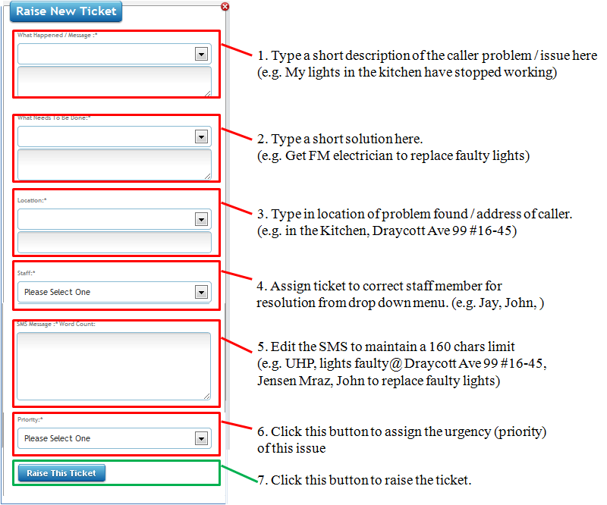

**Figure 4b: Raising of New Ticket for call / problem resolution**

Upon clicking on the **Raise This Ticket** button, a pop-up (Figure 4c) will confirm to agent that ticket has been raised.

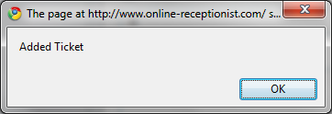

**Figure 4c: Ticket Raised confirmation pop-up dialog box**

## 4.2 Managing Open Tickets

Call Agents can do four actions with Open Tickets / Issues using the below buttons as shown in Figure 4f

* **Show** **Details**: Display the original ticket issue
* **Add** **Message**: For agent to add on any additional message on issue, if required on ad-hoc basis.
* **Escalate**: This button is used for escalation to upper management if issue is not resolved within allocated time.
* **Close**: For closure of ticket when problem resolution is in place.

Below is an example of an Open Ticket Item

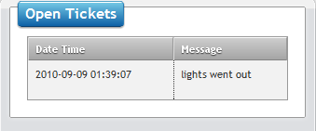

**Figure 4e: Open Ticket window**

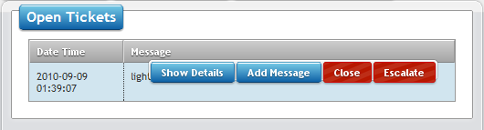

**Figure 4f: Dynamic Ticket Options** **displaying when the user has “mouse-over” ticket.**

### 4.2.1 Viewing Details of an Open Ticket

Click on the “**Show Details**” button to have the ticket details displayed as shown in **Figure 4f,** when you move your mouse over the Open Ticket.

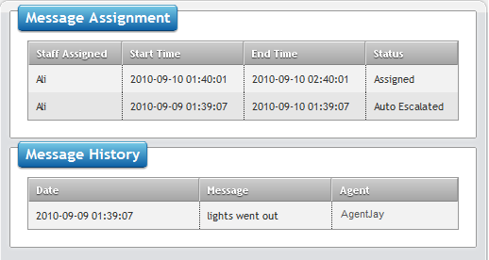

**Figure 4g: Details of an Open Ticket.**

As shown in the **Message History** in Figure 4g, agents can trace the history of an open ticket from the message originally logged by the caller, and the agent engaged. Any additional messages subsequently logged by the same caller on the same issue can also be recorded in this section, when using the **Add Message** functionality, covered in section 4.2.2

It also shows the ticket assigned and who is responsible for the ticket resolution, in **Ticket Assignment**

If the ticket is not closed within the allocated time period, the ticket will be auto-escalated and the assigned person will be sent a reminder notice.

### 4.2.2 Adding a Message to an Open Ticket

To add a new message to follow-up on an Open Ticket as requested by the caller, agents can click on

the “**Add Message**” button as shown in Figure 4f.

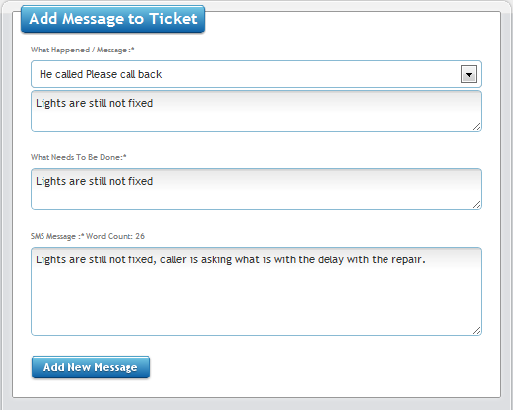

**Figure 4h: Adding message to an open ticket.**

Agent can add new messages by entering the form fields and clicking on the **Add New Message** button.

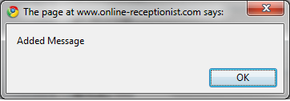

A **“Added Message”** confirmation dialog box will appear to confirm that message has been added to the open ticket.

### 4.2.3 Escalating an Open Ticket Manually

In some cases, the issue may have become more urgent or serious, and agent who are notified by the caller of such urgency, can manually escalate the issue by clicking on the **Escalate** button as shown in Figure 4f.

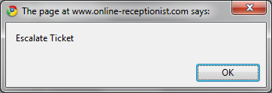

A ticket escalation confirmation dialog box will appear to the agent to complete this process.

### 4.2.4 Closing an Open Ticket

Agents have to close open tickets when assigned personnel have advised them that the issues have been resolved.

To close an Open Ticket, agents can click on the “**Close**” button as shown in Figure 4f.

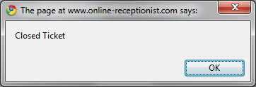

A “**Closed Ticket**” confirmation dialog box will appear to the agent to complete this process.

# 5. Warm Transfer

When a caller requires the attention of an estate management personnel from different department for a problem resolution. Agents can assist callers by connecting the call directly to personnel from various team.

The respective team managers are:

* Cleaning Supervisor
* Chief Security
* Technical
* Condo Manager
* Chief Concierge
* Technical Help Desk

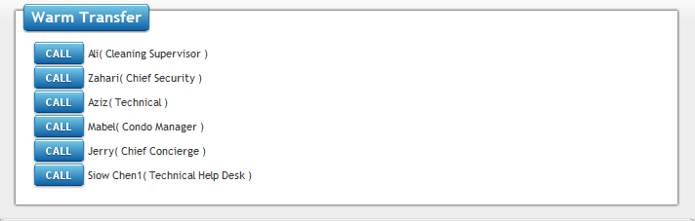

**Figure 5a: Warm Transfer Switchboard**

Clicking on the call button beside the various team will conference the caller, agent & the team leader in the same call for quick problem resolution. After connecting the caller with the respective team manager, agents can then proceed to end their participation in the call.

# 6. Concierge Services

Concierge Services like taxi reservations can be made via the **Agent Dashboard > Concierge** menu tab as shown in Figure 2a.

Agents can assist callers to make taxi reservations for immediate use or place an advance reservation for a later transport provision.

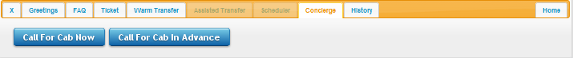

**Figure 6a: Concierge Services – Taxi Reservations**

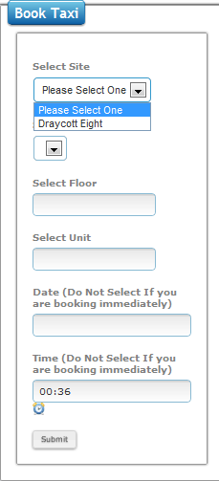

**Figure 6b: Taxi reservation form**

To make a taxi reservation, Agent should do the following:

* Select Site: Click on the drop down menu to select a site location the taxi should pick up the caller from.
* Select Block: Click on the Block number the caller is to be picked up from.
* Date: if reservation is for today, leave empty, else enter advance date of reservation.
* Time: if reservation is immediate, leave empty, else enter advance time of taxi pickup.

# 7. History

This menu tab allows to agent to track the call history of existing callers.

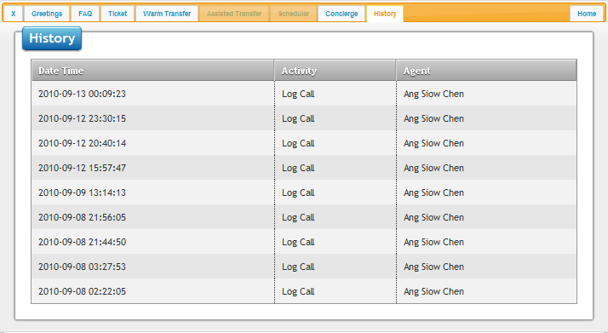

**Figure 7a: History Tab and call log**